Royal College of Psychiatrists Neurodevelopmental Psychiatry Special Interest Group Autumn Conference
Friday 13th October 2023
Speaker Information

Doctor Peter Carpenter, Chair of the Neurodevelopmental Psychiatry Special Interest Group
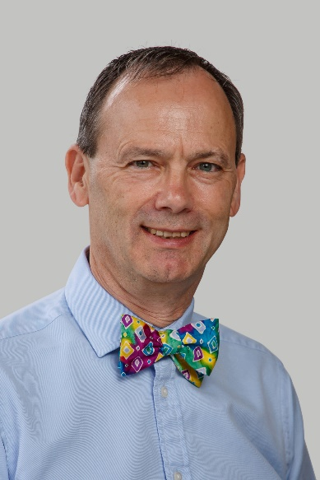 | Peter Carpenter was one of the first medical students at Leicester University. He trained as a Mental Handicap Psychiatrist in Bristol and was consultant there until he retired in 2012 to work with the Public Guardian. He has been closely involved in Autism for many years and is now the chair of the NDPSIG.
Associate Professor Samuel Tromans, Academic Secretary of the Neurodevelopmental Psychiatry Special Interest Group
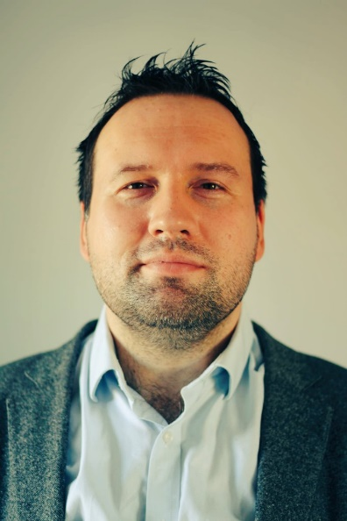 | Samuel Tromans is Associate Professor of Psychiatry in the SAPPHIRE Group, Department of Population Health Sciences at the University of Leicester, as well as an Honorary Consultant Psychiatrist in the Adult Learning Disability Service at Leicestershire Partnership NHS Trust. His research interests include Neurodevelopmental Conditions and Psychiatric Epidemiology, and he is currently working on the 2023 Adult Psychiatric Morbidity Survey, and the book 'The Psychiatry of Intellectual Disability Across Cultures' (Oxford University Press), scheduled for release in late 2023, among other projects.
Doctor Chika Agbo-Umegbolu, Higher Trainee in Psychiatry of Intellectual Disability, Leicestershire Partnership NHS Trust
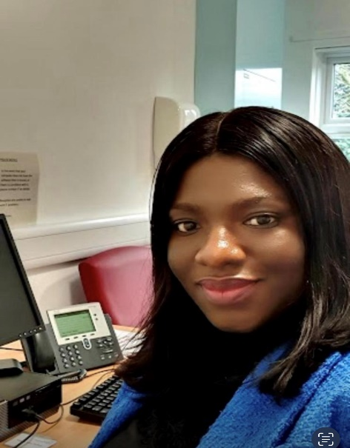 | Chika Agbo-Umegbolu is a Specialty Registrar in Psychiatry of Intellectual Disability, and is supporting with the organisation of this event.  She is currently working as an ST4 in outpatient community learning disability service at Leicestershire Partnership Trust.  She is passionate about rural medicine and has participated in several medical outreaches, creating awareness on mental health, and worked on several community development projects in affiliation with the Niger Delta Development Commission in Nigeria.
Professor Samantha Johnson, Professor of Child Development, University of Leicester
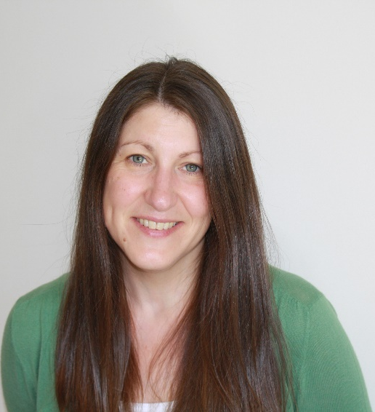 | Samantha Johnson is a Professor of Child Development at the Department of Population Health Sciences, University of Leicester. Her research interests are focused on the study of the developmental consequences of preterm birth and she has a programme of research focused on understanding and improving psychological and educational outcomes for children born preterm. Her research includes longitudinal birth cohort studies and clinical trials of perinatal and neonatal interventions. Samantha has contributed to national working groups including the NICE Guideline Committee for the developmental surveillance of children born preterm guideline, and she is a member of the Strategic Research Group of the British Academy of Childhood Disability and the Neonatal Clinical Studies Group. She is a Chartered Psychologist and Associate Fellow of the British Psychological Society.
Ms Zoe Morgan, Medical Statistician, Neurodevelopmental Psychologist, and Epidemiology Fieldwork Manager, University of Leicester
 | Zoe Morgan is an experienced medical statistician, neurodevelopmental psychologist and epidemiology fieldwork manager, with experience in clinical trials, study design, reporting and statistical analyses. Zoe currently works on the Adult Psychiatric Morbidity Survey (APMS) series, carry out semi-structured clinical psychiatric interviews and managing fieldwork. Additionally, Zoe is working on a randomised clinical trial - SerTRaline for AnxieTy in adults with a diagnosis of Autism (STRATA). The STRATA study aims to find out whether the medication sertraline is an effective treatment for anxiety in adults with a diagnosis of autism. During recent research work, Zoe has developed a keen interest in adult psychiatric conditions and their possible risk and protective factors and how interventions could work towards reducing symptoms. Zoe is currently undertaking a PhD in the epidemiology of adult Attention Deficit Hyperactivity Disorder (ADHD) and Autism Spectrum Disorder (ASD), in the adult general population.
Professor Terry (Traolach) Brugha, Professor of Psychiatry, University of Leicester
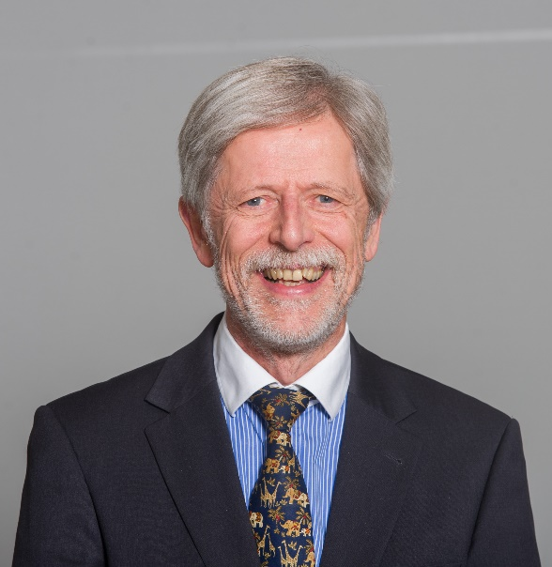 | Terry Brugha developed the world's most widely used measure of stressful life events, the List of Threatening Experiences, and has completed the world's first national, adult general population programme of surveys of the epidemiology of autism in adulthood. He leads a long-term programme of clinical trials on the prevention of perinatal depression. Terry is chief editor of the WHO Schedules for Clinical Assessment in Neuropsychiatry (SCAN version 3) incorporating autism and ADHD. He is an elected member of the Academy of Europe.
Professor Raja Mukherjee, Adult Learning Disability Consultant Psychiatrist, Surrey and Borders Partnership NHS Trust
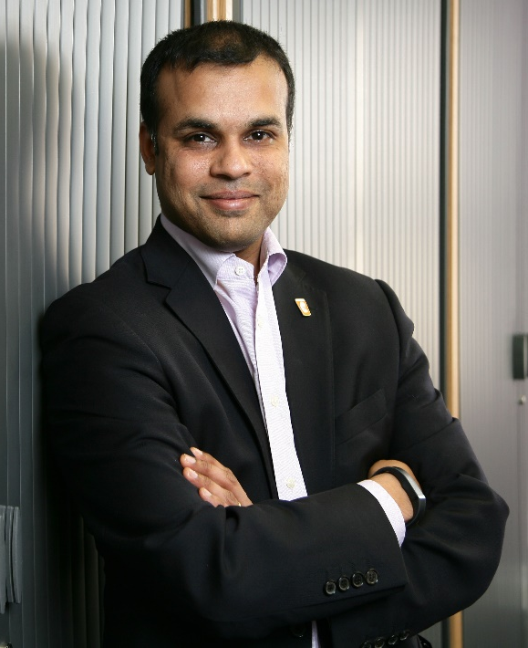 | Professor Raja Mukherjee is an Adult Learning Disability Consultant Psychiatrist for Surrey and Borders Partnership NHS Foundation Trust, with interest in the management of developmental disorders across the lifespan. In September 2009 he started the first NHS based specialist Foetal Alcohol Spectrum Disorders Behavioural Clinic.  He has also acted as an invited advisor to the BMA board of science, The Department of Health. In 2015 Prof Mukherjee also gave evidence to the first All Party Parliamentary Group on FASD at the House of commons. Prof Mukherjee is a member of the NICE quality standards group for FASD. He is currently the only UK representative to a US, NIH sponsored initiative to consider the research criteria for FASD.  In wider work, he is currently Clinical Lead for Adult neurodevelopmental services provided by Surrey and Borders including Adult ASD and ADHD services across Surrey, Hampshire and Portsmouth. He is an executive committee member and Finance Office of the RCPsych SIG on neurodevelopmental disorders, and an Executive member of the ID Faculty.  Prof Mukherjee was awarded an MBE for his work related to FASD in the Kings Birthday Hours list in June 2023.
Doctor Ulrich Müller-Sedgwick, Consultant Psychiatrist and Lead Clinician, Government of Jersey
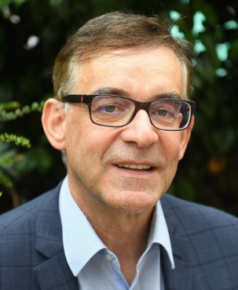 | Ulrich Müller-Sedgwick, MD (Uni Würzburg) PhD (Uni Leipzig) works for the Government of Jersey as consultant psychiatrist and lead clinician for adult neurodevelopmental pathways. From 2017-21 he was the lead clinician for the Barnet Enfield Haringey (BEH) NHS Adult ADHD Service in North London. From 2003-17 he was based in Cambridge, where he developed the Adult ADHD Service for Cambridgeshire and Peterborough NHS Foundation Trust (CPFT) and directed an Adult ADHD research group at the Department of Psychiatry, University of Cambridge.  Ulrich is a member of RCPsych committees (Neurodevelopmental Psychiatry Special Interest Group (NDPSIG) & Psychopharmacology) as well as founding executive committee member (since 2009) and former president (2019-21) of the UK Adult ADHD Network (www.UKAAN.org). He teaches at UK universities and is a regular speaker at national training events and international scientific conferences. He has published more than 140 book chapters and papers (Google h-index 56).
Doctor Jane Sedgwick-Müller, Senior Lecturer and Programme Manager for Mental Health Nursing, Government of Jersey
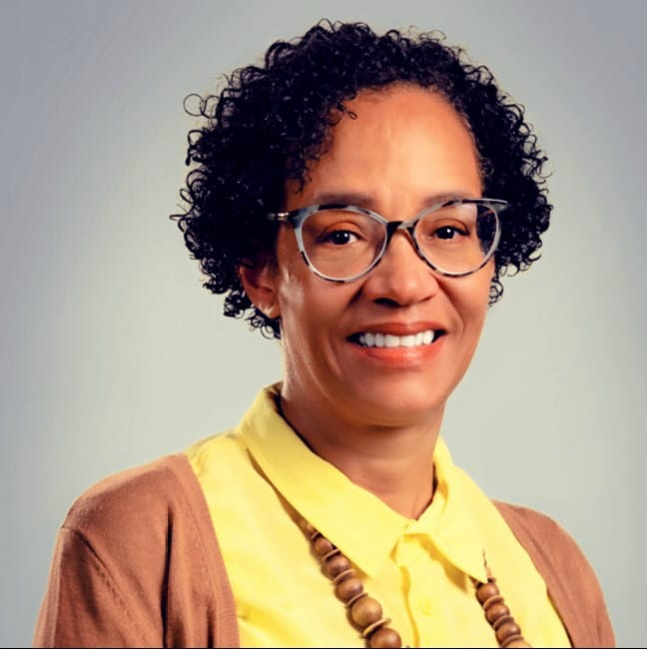 | Jane Sedgwick-Müller works full-time for the Government of Jersey as a senior lecturer and programme manager for mental health nursing on the Island. She is a specialist mental health nurse in neurodevelopmental disorders, an active researcher, public speaker, psychosocial therapist/coach in adult ADHD, executive board member of the UK Adult ADHD Network (UKAAN) and professional advisory committee member of ADDISS: The National Charity for ADHD Information & Support in the UK. Her PhD project with the Institute of Psychiatry, Psychology & Neuroscience, King’s College London, focused on the impact of ADHD on the educational outcomes of university students and usefulness of disability support in promoting positive learning experiences. She received the Royal College of Nursing 2020 Muriel Fleet Award for outstanding achievement in professional development, and the 2020 Genius Within Award for Neurodiverse Research of the Year, sponsored by Microsoft.
Doctor Fiona Gullon-Scott, Senior Lecturer on Clinical Psychology Doctoral Programme, Newcastle University
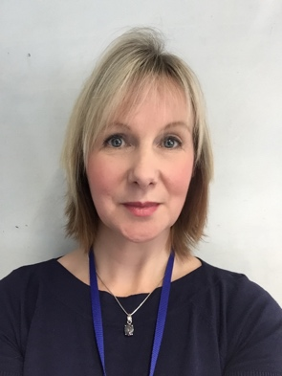 | Fiona Gullon-Scott is a Senior Lecturer on the Clinical Psychology Doctoral Programme at Newcastle University, and Honorary Senior Lecturer with Tizard Centre, University of Kent. An HCPC registered Clinical Psychologist, Fiona has been working as an autism and neurodiversity specialist for almost 30 years. Research interests currently include autism in females, social injustice relating to autistic families, and improving therapeutic support for mental health in autism, as well as ongoing collaboration with Prof Terry Brugha and his team.
Doctor Marie Boilson, Consultant Psychiatrist, Republic of Ireland
 | Marie Boilson is a consultant psychiatrist who has recently moved to the Republic of Ireland to set up an Adult ADHD team as part of the National Clinical Programme in the HSE for adult ADHD. She previously was a clinical director in NHS Fife where she was involved in developing a local NDD pathway. She was chair of the Royal College of Psychiatrists in Scotland Working Group in ADHD and co-author of a college report on adult ADHD. She has worked for the National Autism Implementation team from February 2019., developing an adult Neurodevelopmental Disorder Pathway for Scotland
Doctor Marion Rutherford, National Autism Implementation Lead, Scotland
 | Marion Rutherford leads the National Autism Implementation Team programme of work in Scotland, focussed on evidence informed changes in policy and practice across sectors, to support practitioners to better understand and meet the needs of autistic and other neurodivergent people of all ages, in services and in society. Marion is a speech and language therapist, researcher, practitioner and RCSLT advisor with a strong interest in the evolution of neurodevelopmentally informed and neuro-affirming practice.
Associate Professor Michelle O’Reilly, Associate Professor of Communication in Mental Health, University of Leicester
 | Michelle O’Reilly (BSc [hons], MSc, MA, PhD, PGCAPHE, SFHEA, C.Psychol.) is an Associate Professor of Communication in Mental Health at the University of Leicester and a Research Consultant and Quality Improvement Advisor for Leicestershire Partnership NHS Trust. Michelle is also a Chartered Psychologist in Health. Michelle has research interests in mental health and social media, self-harm and suicidal behaviour, neurodevelopmental conditions, and child mental health services, such as mental health assessments and family therapy. Michelle has expertise in qualitative methodologies and specialises in discursive psychology and conversation analysis. Michelle has written considerably in the field of research methods and has written practical guidance for clinical practitioners on how to do qualitative research.

