Dear Occupational Psychiatry SIG members

I hope that 2021 has not been too challenging a year for you all and that 2022 will be better still. The OPSIG executive continue to beaver away and are working with the College central team to finalise a position statement on Occupational Psychiatry which I believe will be an important building block for the College’s work on this topic. In my view, it is essential that work is viewed as an important treatment outcome for any professional who provides mental healthcare.

The last couple of years have exposed many people to traumatic events and it is thus very timely that the College has published updates of the PTSD information leaflet and the information on coping after traumatic events. This information should be useful both to individuals and employers and I would encourage anyone who works with trauma-prone organisations to ensure that those in senior management positions are aware of these.

It is also good to see that the Health and Safety Executive continue to view mental health at work as important; hopefully more employers will begin to view it the same way.

Lastly, I have been the chair of the OPSIG for over three years now and next year will see an election for my successor. If you might be interested in the role, please do keep your eye out for the advert [around or just before Easter time I suspect] and/or get in touch if you would like any more information about the role from my point of view.
I hope you have a restful Christmas break.

Best wishes

Neil

Neil Greenberg
Professor of Defence Mental Health and Chair of the Occupational Psychiatry Special Interest Group

SIG news and announcements:

Join us via Zoom on 26 January 2022 at 4pm for a live webinar discussing the Mental Health Challenges in Returning to Work in the World of Covid. Professor Sir Simon Wessely will chair the event and will be joined by:

- Dr Rikard Moen - Chief Medical Officer of Optima Health.
- Dr Tim Nicholson – Honorary Consultant Neuropsychiatrist within SL&M and expert in functional neurological disorders.
- Beverley Fairbank – HR director for manufacturing and employee relations at Jaguar Land Rover.

A link to this event will be publicised via this mailing list and via our Twitter account @rcpsychOHSIG.

The Society of Occupational Medicine hosts free and subscription webinars often with relevance to psychiatry. You can access these webinars here.

Congratulations to the OPSIG members who spearheaded the London Nightingale Hospital Mental Health Team, voted RCPsych’s Psychiatric Team of the Year 2021 (working age adults).

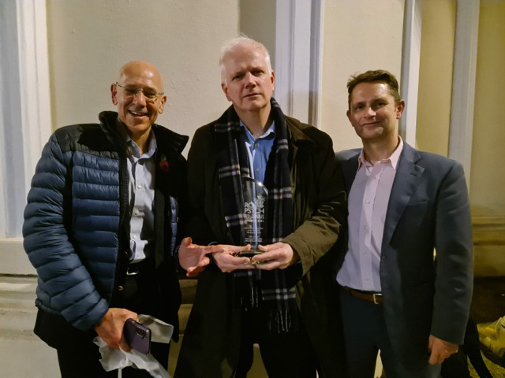

This was a great example of occupational psychiatry in practice, with the development of NHS staff support plans that were later adopted by many NHS Trusts. If you are aware of other occupational psychiatry initiatives that should be shared with the SIG, contact us via Twitter or by sending an email to RCPsychOHSIG@hotmail.com.

The minutes of the SIG executive committee meetings are posted here.

