**PIPSIG Drop Ins – ‘The Best Bits’ – Friday 30 June 2023**

**Speaker bios**

**Dr Mona Freeman, Chair**

Mona is a consultant child and adolescent psychiatrist who has worked as a sole practitioner in independent practice since 2019 in Jersey, Channel Isles.

Never having previously considered working independently, Mona found she simply couldn’t otherwise square the circle of work and family life without the flexibility that working for herself has brought.

Mona was co-opted onto the PIPSIG Exec Committee in 2021 and took over the organisation of the monthly drop ins for PIPSIG members from then. She was elected Chair in 2023.

Mona has always been keen on public engagement and education and was Series Editor of the Mental Health and Growing Up College leaflets in the early 2010s as well as contributing book chapters to RCPsych publications *The Mind - A User’s Guide* and *The Young Mind*. She was awarded the Laughlin Prize by RCPsych in 2003.

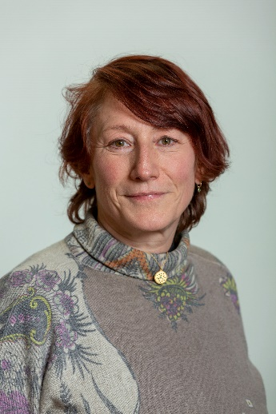**Dr Rachel Gibbons**

Rachel has worked in the NHS over the past 20 years in various psychiatric settings as a consultant psychiatrist and consultant medical psychotherapist. She has recently been working as the National Director of Therapies for the Priory Group. She is a psychoanalyst and group analyst and current Co-Chair of the Patient Safety Group, Chair of the Working Group on the Effect of Suicide and Homicide on Psychiatrists and Vice-Chair of the Psychotherapy Faculty, at the Royal College of Psychiatrists.

She has recently had 3 papers published on the effect of suicide on clinicians, she is co-editor of the Royal College of Psychiatrists book ‘Seminars in the psychotherapies’. (Gibbons, R. and O'Reilly, J. eds., 2021. Seminars in the Psychotherapies. Cambridge University Press.) and has her most recent paper on the nature of mental illness published in [BJPsych Advances](https://www.cambridge.org/core/journals/bjpsych-advances/article/mourning-process-and-its-importance-in-mental-illness-a-psychoanalytic-understanding-of-psychiatric-diagnosis-and-classification/AADC76B72F52556A897A41B131A25D37) in Psychiatric Treatment in March 23

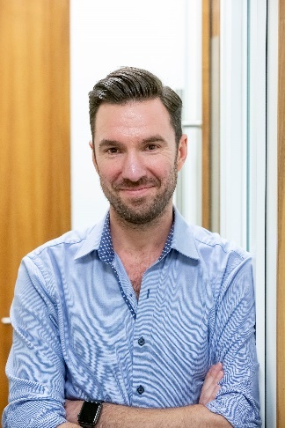**Dr Ed Burns**

Ed has been a Consultant since 2011.

He is an independent Consultant with previous roles at  Priory Hospital Roehampton and as a Consultant Psychiatrist in the NHS.

He has worked as a medical manager as a “Darzi Fellow”,  an Associate Medical Director, a Medical Director and a Clinical Director.

**Dr Jonathan Hellewell**

Jonathan trained in psychiatry in Manchester.

After some years as a higher trainee, Jonathan worked at the University of Manchester, as Research Fellow and Lecturer, his main research interests having been psychopharmacology and the neurobiology of major mental illness.

Jonathan then took a senior international management role with a multinational pharmaceutical company.

In 1998, Jonathan returned to full-time clinical practice, taking a Consultant post in Adult psychiatry, in the Trafford district of Manchester. For many years, Jonathan had responsibility for the patients from his catchment area, in both community and inpatient settings.

For approximately twelve years, prior to retiring from NHS Practice, in 2017, Jonathan held the position of Lead Consultant.

Jonathan maintained his interest in pharmaceutical medicine and drug development, after leaving the pharmaceutical industry.

For over twenty years, Jonathan has been involved in preparing psychiatric reports, at first, in criminal matters, but more recently in the civil setting. Jonathan finds medicolegal work to be both challenging and stimulating. Latterly, he has tended to focus on the more complicated cases, working now on a part-time basis.

Jonathan has acted as mentor, for a number of psychiatrists who are setting out on a career in independent practice.

Jonathan has been elected the Finance Officer of PIPSIG. He sees his role as being to assist the PIPSIG Executive Team in delivering a range of activities that will support the professional development of psychiatrists working in the private and independent sectors.

Jonathan has helped to facilitate a number of PIPSIG Drop-In Sessions. He finds these sessions to be stimulating and rewarding, providing, as they do, a valuable opportunity for psychiatrists working in the private and independent sector to gain mutual support and to learn from one another.

**Dr Rick Driscoll**

Rick is an independent consultant general adult and forensic psychiatrist, now working primarily as a Medical Member of the 1st tier Tribunal (mental health) and as a CQC Second Opinion Appointed Doctor.

Rick also has a small medical legal practice and Practising Privileges at The Priory Hospital Bristol.

Over the last 30 years, he has held various consultant and medical management posts.

**Dr Simmi Sachdeva-Mohan**

****Simmi has been practicing Psychiatry since 1995 and is a Gold Medallist from Bombay University for her MD (Psychiatry). She has been a Consultant Psychiatrist since 2009 and is a Fellow of the Royal College of Psychiatrists. Simmi has practiced psychiatry in both Eastern and Western cultures.

She has expertise in the assessment, care and treatment of mentally ill offenders, substance misuse and dual diagnosis, personality disorders, adult ADHD, mental health of refugees and asylum seekers, Forensic and Perinatal Psychiatry. She is a specialist advisor to the CQC and has worked with the College as a Regional Advisor, College assessor, CESR assessor and a peer reviewer for ECTAS.

**Dr Iain Grant**

Iain is an adult consultant Psychiatrist and chartered manager of the CMI.

Iain's passion for innovation has found him juggling several roles, not least, the communications executive for PIPSIG.

Iain has extensive experience championing digital transformation projects on a large scale and has helped to influence the national Digital Clinical Safety Strategy to promote the use of responsible Health Technology.

As the Clinical Safety Officer to Thalamos Ltd, Iain has helped to lead the digitisation of the Mental Health Act Pathway accross the UK to improve transparency and the availability of vital health data.

Iain's entrepreneurial flare manifests as the Medical Director and CQC-registered manager of RTN Medical, an independent Psychiatric clinic operating in Harley Street.