PREPARED BY
LAST REVIEWED ON
SEPSIG 14the ENxecutivee Cwommitsteeletter
Dr Jack Tagg with the help of
27/04/2023
Volume 1
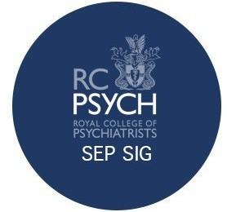

SEPSIG 14 Overview

On the 31st of March 2023, the 14th SEPSIG conference was held virtually due to the threat of train strikes impacting on delegate travel plans. Despite not being able to meet at the Institute of Sport & Exercise Health (ISEH), London as planned, the switch to virtual allowed additional ﬂexibility and resulted in a greater number of delegates being able to attend. This conference focussed primarily on the ‘Exercise’ aspect of our Special Interest Group.

Symposium 1

The morning symposium focussed on exercise, dance and mental health. This included insightful talks from leading clinicians, researchers and media representatives in this exciting area. The ﬁrst talk was by Dr Brendon Stubbs, a clinical-academic physiotherapist, who is in the top 1% of highly-cited researchers in this area. His fascinating talk focussed on the data and research behind how physical activity can be used to treat and manage mental health conditions.
Following on from this, Dr Claire Gillvray (SEPSIG’s very own Exercise and Mental Health Lead) and Lucy Hibben gave an interesting talk on their company, Cognitive Sports Therapy and how it can be tailored effectively to individual cases. To end the talk, Lucy Hibben provided an interactive breath-work and mindfulness session- a great way for everyone to get involved through the virtual interface!

Next up was Dr Catherine Lester, who is consultant lead for Moving Medicine and Northampton Saints’ team doctor. She gave an inspiring lecture which further explored the link between inactivity, mental health issues and physical health co-morbidity. One of the most striking points was how physical demands vary with age and how the ‘sedentary epidemic’ impacts across the lifespan.
The ﬁnal talk was provided by Dr Nicoletta Lekka (SEPSIG’s Dance Liaison lead) with her talk on her on ‘Dance for Health’, which covered how dance can positively impact on wellbeing and facilitate non-verbal communication. The symposium concluded with an expert panel Q&A session.

Symposium 2

The second symposium included an interactive workshop session exploring research opportunities within sport & exercise psychiatry. This was led by Dr Alan Currie, former chair of SEPSIG, and covered multiple topics, including: how to set up a ‘powerful’ study, the theory behind how to ﬁll important gaps in current research and a general overview of the current landscape of key exercise related research.
This was a fantastic opportunity for trainees to network and gain insight as to how they can get involved in future research opportunities. The conference concluded with a business meeting, the minutes of which can be found attached to the bottom of this newsletter- this will include updates from all of our committee members.

Burnley's Success
Dr Allan Johnston, former SEPSIG deputy chair, recently co-authored a paper based on his work at Burnley Football club. The paper is titled, "Treating mental stress in elite footballers using a stigma-free psychological approach: the Power Threat Meaning Framework." It focusses on how stress can impact player performance, frameworks that can be used to guide therapeutic intervention and the importance of de-stigmatising mental health in football. The full paper can be accessed via links shared on our Twitter page or directly through Cambridge University Press.
Shortly following this paper Burnley were promoted from the Championship back into the Premier League. Obviously, our congratulations go to all involved but is this not evidence of how important it is to manage the mental health, as well as the physical health, of elite athletes to enable them to reach their peak performance?

Teaching Trainees

On Friday 17th March, Dr Jack Tagg (SEPSIG Social Secretary) and Dr Thomas McCabe (SEPSIG Education Lead) gave a talk on Sports Psychiatry to ﬁnal year medical students and foundation doctors in the Trent deanery as part of a conference to inspire future psychiatrists. Jack focussed on outlining what factors make elite athletes different to the general population, whereas Dr. McCabe used his expertise in Old Age Psychiatry to focus on repetitive head injuries in sport and their link with dementia.

On Friday 21st April 2023, several members of the SEPSIG executive committee hosted the Cygnet Health's medical academic program on Sport & Exercise Psychiatry. This was chaired by Dr Amit D Mistry (current chair) with talks from Dr Caz Nahman (current deputy chair), Dr Thomas McCabe, Dr Jennifer Keal and Dr Claire Gillvray. The talks were well received with excellent feedback from Cygnet Health.

Member Achievements

Dr Jennifer Keal (SEPSIG Executive Committee's Trainee Rep) and Dr Claire Gillvray (SEPSIG Exercise and Mental Health Lead) recently completed the London Marathon in fantastic times. Great to see our members practicing what they preach and inspiring those around them- congratulations Dr Keal and Dr Gillvray!

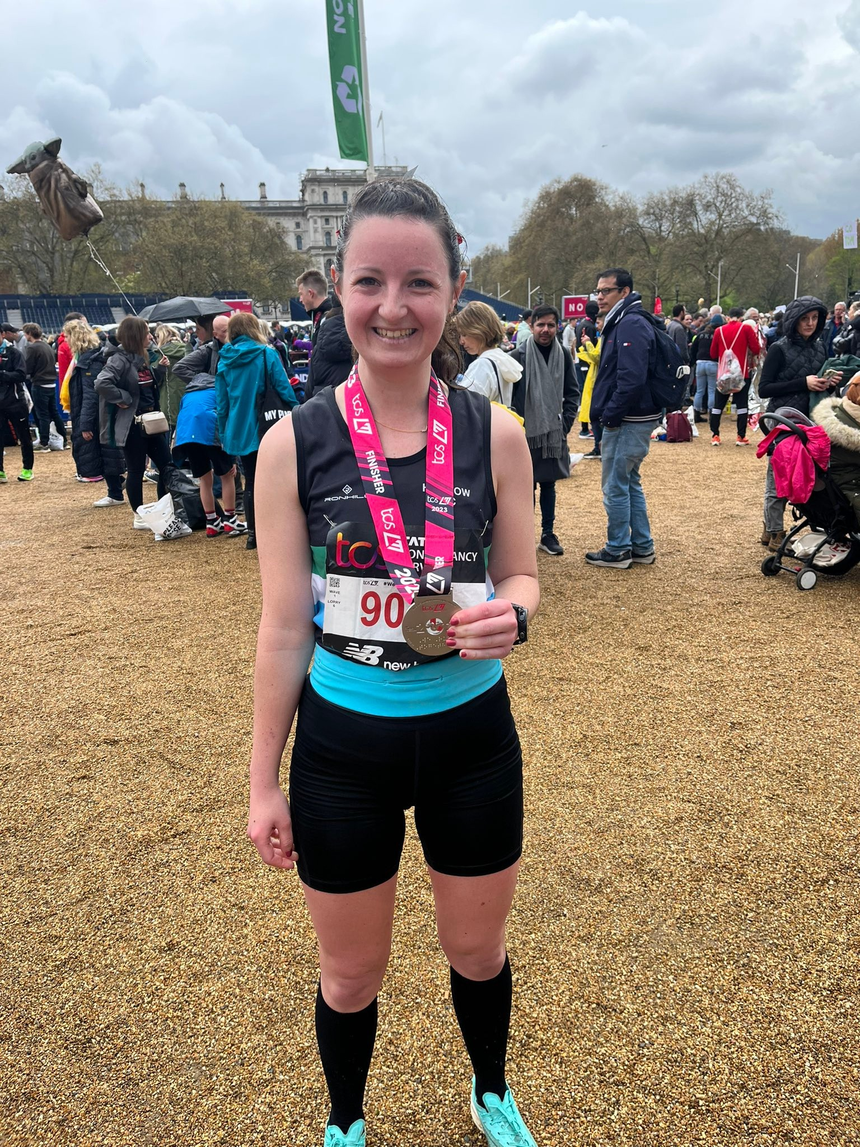

Asics Europe and
Athlete Mental Health
In April 2023, Dr Mistry was part of the Asics expert panel held at the Asics ﬂagship store on Oxford Street, London. This was to celebrate the upcoming London Marathon. He discussed his role as the consultant sports psychiatrist to Asics Europe athletes and shared the stage with Asics frontrunners and sponsored athletes
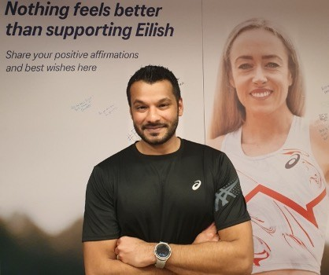

The Journal of Sports
and Exercise Psychiatry

For those who enjoyed reading Dr Johnson's paper or who found Dr Currie's symposium on research in Sports Psychiatry psychiatry inspiring, the Journal of Sports and Exercise Psychiatry are still inviting submissions of manuscripts for publication. The overarching topic they seek to cover is: Sports Medicine and Sports Psychiatry. Further details can be found on their Twitter (@SportsPsychJ). The deadline for submissions is June 15th 2023.

Future Events and
Editions
The plan going forwards is for this newsletter to be released biannually in line with our SEPSIG conferences. The plan is to cover a whole range of topics, including:
Current Research
Articles covering hot topics or situations related to Sports and Exercise psychiatry
Member achievements, updates and career progression Summary of the most recent SEPSIG conference
We are a very welcoming special interest group so if you are a new or existing member and feel that you have something to contribute to a volume of the newsletter going forwards then please reach out to us using our Twitter page!

Please follow our social media for updates around future events and all current affairs related to Sports and Exercise Psychiatry. SEPSIG 15 is currently planned for Wednesday 22nd November 2023 and will be hosted at the Royal College of Psychiatrists Headquarters in London. Pencil it into your diaries and we hope to see you all there!
@RCPsych_SEPSIG

SEPSIG 14 Business
Meeting Minutes
- Meeting Details: Date: 31st March 2023 (Virtually, 41 participants)

- Review of previous business minutes from SEPSIG 13 performed

- Potential Future SEPSIG conference topics
  - Dr. Claire Gillvray suggests neurodiversity alongside athlete speaker, supported by Dr. Caz Nahman, Prof Alan Currie and Dr. Amit Mistry.
  - Suggestion of gambling addictions topic raised by Dr. Tagg

- Financial Update by Dr. Caz Nahman
  - Explained that big savings were made by moving conference online.
    - Explained that catering costs and hybrid meeting costs have gone up this year and that they may only be feasible for much larger meetings.
  - Stated that we made around £600 profit this year.
  - Shorter webinars seem to be making the most profit➔possible avenue for the SIG to make profit through shorter form talks on ideas of interest.

- Exercise updates by Dr Claire Gillvray

  - Mentioned that we need to really demonstrate the need for research in this area and target a larger audience to achieve meaningful results.
  - CEO of MIND and Parkrun are very keen to be involved with RCPsych projects and exercise interventions.
    - Project is still in the scoping phase but it seems as if there is big potential despite potential logistical stumbling blocks.
    - Request for trainees to help out with project.
  - SEPSIG Strava group has been set up and shared on SEPSIG Whatsapp.
    - Possibility of creating SEPSIG social group to co-ordinate getting involved in these challenges.

- Dance updates by Dr Nicoletta P Lekka

  - Dr Lekka has delivered 2 webinars recently, one for British Psychological Society and another for One Dance UK in Limerich, Ireland.
  - Dr Lekka also attended the European Psychiatry conference where trainees completed a follow up survey on the awareness of physical exercise interventions in acute mental health patients.

- Trainee updates by Dr Jennifer Keal
  - Whatsapp SEPT group has increased to 30 people.
  - Recaps informal January event on how to get involved in SEPSIG and research opportunities.
  - Discussion regarding ISSP diploma and a potential study group. It has been on the agenda for a while and we discussed whether there is enough trainees to make it worthwhile➔the general consensus suggests there is!

- Education update by Dr Thomas McCabe
  - Recaps the Choose Psychiatry Trent Deanery presentation. Possibly a slightly limited time slot but we did well to get our message across with good level of engagement.
  - Dr McCabe has been in touch with the Scottish Medical schools but has yet to agree a specific timeslot.
  - Dr Mistry and Dr McCabe discuss potentially organising a talk through SEM contacts.
  - Dr Mistry is going to be involved with a Maudsley podcast next week which could be a good pilot for the podcast we discussed at the last meeting.

- Social Media Update by Dr David Prossor

  - Current follower number on the SEPSIG Twitter account, 1,143. That is a positive gain of approximately 240 followers since our last conference SEPSIG13
  - As Alan highlighted in his talk, we have successfully gained permission from the publisher and set up the Sport Psychiatry Journal’s own Twitter account. We are working closely with Malte (Chief editor) and his team. We will be meeting online with the communications lead for the Swiss Sports psychiatry group on the brand and plan for the tweet content

- Social update by Dr Jack Tagg

  - Explains that unfortunately moving the event online led to the cancellation of the Thursday night meal and Friday evening drinks that were planned.
  - Also recaps the Trent Choose Psychiatry lecture and touches on the potential for a SEPSIG podcast.
  - Email sent to the chat so colleagues can send over any research details that can be circulated in the biannual newsletter that will be debuting shortly after the conference.
  - Dr Tagg to message trainee Whatsapp chat for the idea of online socials.

- Research and IOC Updates by Prof Alan Currie
  - Praised social media efforts of Sports Psychiatry Journal.
  - Sports Psychiatry journal abstracts and applications are open until the end of April 2023 and they are particularly keen on lifestyle interventions.
  - Prof Currie mentions a research institute for Sports Psychiatry that is opening up in Zurich and that trainees can reach out for possible secondments.
  - Prof Currie mentions his role sitting on ISSP mentorship boards and topics that he has covered, including bipolar disorders.
    - Dr Nahman responds stating that she has been similarly involved with eating disorders content.
  - Prof Currie mentions Athletes 365 and a social media in athletics piece he completed with Eilish McColgan.
  - Prof Currie mentions the SMAT1 screening tool and what possible future versions would include, suggesting the example of OCD symptoms.
  - EIS
    - Discussion around the mental health strategy for the Paris games of 2024.
    - Prof Currie explains the updates around the coding systems upgrades and how they will allow for more nuanced data collection for a variety of psychiatric disorders in athletes.
    - Prof Currie discusses the EIS expert panel that delivers mental health advice to athletes and how it is currently lacking psychiatrist input. There are opportunities out there for colleagues.
      - Prof Currie puts his email in the chat so people can contact him about this opportunity
Any Other Business
  - Discussion around how to grow SEPSIG led by Dr Caz Nahman
    - Can we expand the core curriculum?
      - Dr Claire Gillvray volunteers to get in touch with the Education and Training committee. Catriona from RCPsych will email Dr Gillvray with support.
    - Dr Nahman mentions possibility of linking up with social prescribing group.
    - Prof Currie suggests the possibility of doing joint conferences to boost numbers.
      - Dr Tagg mentions the idea of joint webinars- various members suggest collaborating with eating disorders, old age psychiatry and social prescribing.
      - For a full conference Prof Currie suggests that this would take 12-18 months
of planning. With this in mind, could short form webinars be an ‘easy win?’

  - Discussion around Social Exercise events led by Dr Mistry
    - Dr Mistry to add swimming and cycling to SEPSIG Strava
    - Dr Gillvray suggests NHS Strava run to be completed at your local park run site and for us to spread the word amongst colleagues.
  - SEPSIG 15 potential dates
    - 11/09/23 and 22/11/23 are the only dates not in the school holidays.

