SEPSIG 11 Virtual Online Conference: 14th October 2021 2-5PM
Symposium 1: Tokyo Olympics, Mental Health De-brief (90 Minutes)
Speakers: Prof Alan Currie, Dr Allan Johnston, Dr Carla Edwards
Chair: Dr Amit D Mistry

Major Games events such as the Olympic Games requires a convergence of physical and mental preparation to allow athletes to achieve peak performances on the World’s biggest stage. Personnel such as coaches, sports scientists, strength coaches, physical therapists, mental performance coaches and psychologists have long been involved as vital components to the athlete support team. The integration of Sports Psychiatrists into this system is relatively new and not yet utilized by all Nations. Symposium 1 will explore leading international insights from Sport Psychiatrist’s who have recently been involved with the Tokyo Olympics.
For the first talk, Dr Johnston will explore the approaches taken in Sports Psychiatry before, during and after the Olympic & Paralympic Games in supporting the mental health of our athletes and staff. Anonymised athlete case studies will be provided to illustrate issues around risk assessment, medication management, deselection and supporting athletes to return home after the highs and lows of elite sport.
This will be followed by Prof Currie will discuss some of the mental health elements in the British medical plans for the recent Tokyo 2020 games. He will describe how these plans were developed and how the English Institute of Sport’s Mental Health Expert Panel (MHEP) were able to contribute. He will make specific reference to the management of mental health emergencies, medication issues and the templates that were adopted to support mental health planning for individual athletes.
The final talk will be delivered by Dr Edwards who attended Tokyo onsite as Sport Psychiatrist to Swimming Canada athletes and staff members. Dr Edwards will be able to provide insights into the how the Canadian mental health strategy and policy compared and contrasted with that of the UK.

Speaker Biographies:
- Dr Allan Johnston

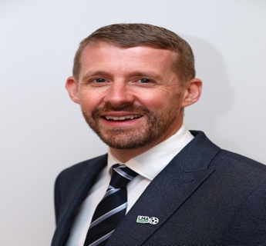

Dr Allan Johnston, MBBS, MRCPsych, Cert.Med.Ed(IU) is a world leading Sports Psychiatrist based in the United Kingdom.
Working with athletes across a range of sport, dance and performance disciplines, his extensive career as an early adopter of Sports Psychiatry has led him to become one of the most trusted and sought-after professionals in his field.
He has been appointed to three key roles within the world of sport:
- As Sports Psychiatrist for The English Institute of Sport (EIS) Mental Health Expert Panel, he supports the mental health & wellbeing of our Great Britain Olympic and Paralympic athletes at the Tokyo Olympic Games and now into the Paris 2024 Olympic cycle.
- Dr Allan is the Consultant Performance Psychiatrist for the League Managers Association (LMA) in a role to guide & shape English football’s Mental Health & Wellbeing programme, providing mental healthcare for managers across the Premier League, EFL divisions, the WSL & FA Women’s Championship
- Recognised by the UK Anti-Doping authority (UKAD) as having specialist expertise in the assessment and management of ADHD, he sits on the UKAD specialist register for ADHD Therapeutic Use Exemption assessments..
The Bradford Bulls RLFC employed Allan as the world’s first Rugby League Sports Psychiatrist in 2012. He now works with athletes across a range of sports, dance and performance disciplines. Since leaving the Bradford Bulls, as Medical Director and Sports Psychiatrist to Synergy Medicine Ltd Allan has developed an independent sports medicine service in Leeds that works with all levels of conditions and injuries in Athletes and Dancers. Allan works with clients on all aspects of Wellbeing & Performance.
In 2016 he co-founded the Royal College of Psychiatrists Sports and Exercise Psychiatry Special Interest Group (SEPSIG) to deliver education & governance for UK Sports Psychiatrists. After serving a 4 year term on the executive as deputy chair, he remains an active member of the group.
In his NHS role Dr Johnston chaired the Derbyshire Suicide Prevention Strategy Group 2013-2018 and led a range of innovations in the region including the development of the regional strategy, a greater involvement of service users in co-producing their own care and leading World Suicide Prevention Day initiatives. Since 2015, over 3 successive years, suicide rates in Derbyshire almost halved. In 2018 the groups work with Public Health on training General Practitioners in Suicide Prevention strategies was nominated for a Health Service Journal (HSJ) award.
He was awarded the Everything in Sport 2019 national award for supporting the mental health of female athletes and was made Yorkshire’s Doctor of the Year 2019 at the YEP healthcare awards – the first occasion this has been presented to a psychiatrist. In 2020 Dr Johnston was part of a team awarded the EIS Collaboration and Teamworking award for supporting the mental health of athletes during the COVID-19 pandemic. In 2021 he was given the International Society of Sports Psychiatry ISSP experienced practitioner in Sports Psychiatry award.
Allan works on a voluntary basis as Sports Psychiatrist and Trustee to State of Mind Sport, a charity aiming to improve the mental health and wellbeing of athletes and their communities. He has published a number of peer reviewed research papers & written chapters for educational textbooks.
He lives with his family in Yorkshire.

- Dr Alan Currie

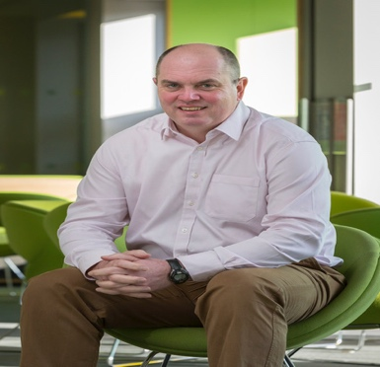
Consultant Psychiatrist MB ChB, MPhil, FRCPsych
Dr Currie is a consultant psychiatrist in a specialist mood disorders treatment and research centre in Newcastle, England (the Regional Affective Disorders Service). He is also a lecturer at Newcastle University and visiting professor at the University of Sunderland in the Department of Sport and Exercise Sciences.
His research interests include recovery, social inclusion, mood disorders and sports psychiatry. He has published in all these areas including editing a highly commended handbook of Sports Psychiatry (2016) and a collection of Case Studies in Sports Psychiatry (2020).
He is founder and a former chair of the Royal College of Psychiatrists Sports and Exercise Psychiatry Special Interest Group (SEPSIG). In 2019 he joined the International Olympic Committee mental health working group and was also appointed to the Mental Health Expert Panel of the English Institute of Sport (EIS). He became chair of the Scientific Committee of the International Society for Sports Psychiatry (ISSP) in 2020.

- Dr Carla Edwards
Dr. Carla Edwards is a Sports Psychiatrist whose practice focuses on the treatment of mental illness and psychological struggles in athletes. Her early years in competitive sport primed her for a career supporting athletes and culminated with induction into the Newfoundland and Labrador Sport Hall of Fame in 2015. She has been an Assistant Professor of Psychiatry in the Department of Psychiatry and Behavioral Neurosciences at McMaster University since 2005.
Her early career focused on crisis stabilization for children and adults balanced with leadership roles in areas of advocacy, collaboration, development, and management. In 2012 she cultivated her passion for sport and built her Sport Psychiatry practice. Dr. Edwards provides consultation and support for high performance, elite, and professional athletes with focus on diagnosis and treatment recommendations pertaining to struggles with mental illness. Performance enhancement strategies are interwoven in the overall approach to wellness. She has treated Olympians and athletes from 10 Canadian National Sport Organizations and is the High Performance Mental Health Advisor for Swimming Canada and Cycling Canada. She has authored several book chapters about Sports in the Covid-19 Era, Psychiatric Emergencies in Athletes, and Depression in Athletes. In July 2021 Dr. Edwards accompanied Swimming Canada athletes and staff to the Tokyo Olympic Games where she provided on site support prior to, and throughout, the event.

Symposium Two: National Anti-Doping Panel proceedings: Protecting the system, protecting athletes.
Speakers: Richard Harry, Jeremy Summers with Q & A session with Dr Tim Rogers.
Chair: Dr Caz Nahman
Our second session will focus on Anti-doping within sport, a controversial topic which often attracts significant media attention. This panel session will include leading arbitrator insights from experts working with Sport Resolutions and the UK's National Anti-Doping Panel (NADP). In addition, clinical aspects such as the athlete story and the challenges related to recent changes to the World Anti Doping Agency (WADA) code will be explored. There will be an opportunity to ask live questions to all panel members questions chaired by Dr Tim Rogers.

Speaker Biographies:

- Mr Richard Harry
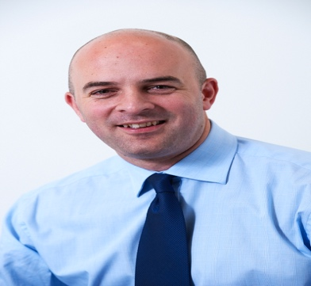

Richard has been Chief Executive at Sport Resolutions since April 2016. Richard joined Sport Resolutions in July 2010 and spent almost six years as firstly Dispute Resolution Manager and then Legal Director.
He is a sports lawyer and was the founder and first Chief Executive of the Welsh Rugby Players' Association. Richard started his career as a specialist employment and sports lawyer at Hugh James Solicitors in Cardiff before joining Clarke Willmott in Bristol.
He left Clarke Willmott to establish the Welsh Rugby Players' Association and has acted as a Consultant to the World Anti-Doping Agency. Richard is a Visiting Fellow to the School of Sport and Exercise at the University of Gloucestershire and has been appointed to the Board of the London-based International Dispute Resolution Centre (IDRC).

- Mr Jeremy Summers
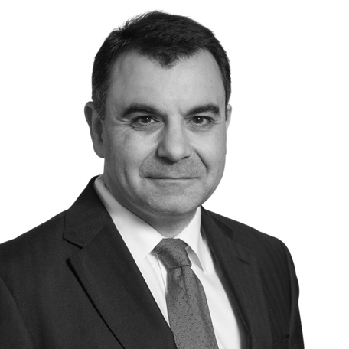
Jeremy Summers is Head of Business Crime at Osborne Clarke LLP and focusses particularly on helping companies and individuals who are involved in investigations relating to all aspects of business crime including corruption, fraud and financial regulation.
Jeremy was appointed to the RFU National Panel (foul play, misconduct, competition and anti-doping) in 2006, and has been a member of the World Rugby Judicial Panel since 2008 for whom his appointments have included the Commonwealth Games 2014, Women’s Rugby World Cup 2010 and 2014 and Rugby World Cup Sevens 2013.
Jeremy was also appointed to the European Professional Club Rugby Disciplinary Panel in 2011 and has been a Six Nations Disciplinary Panel Chairman since 2009. In a bygone era he played competitive rugby and cricket.
He is a member of Sport Resolutions' Panel of Arbitrators and Mediators, and currently sits on the UK’s National Anti-Doping Panel (NADP) operated by Sport Resolutions.

- Dr Tim Rogers

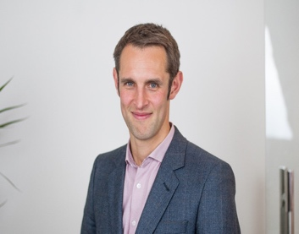
Tim is a sports psychiatrist working across the spectrum of mental health, wellbeing and performance within both elite sport and dance, certified by the International Society for Sport Psychiatry (ISSP). Tim is also an approved expert on the Football Medicine and Performance Association (FMPA) register.
Tim is one of a very small number of psychiatrists to have also completed postgraduate training in applied sport and exercise psychology. For many years, Tim has supported both individuals and teams in elite football, in the Olympic and Paralympic Systems, elite rugby, cricket, tennis, horse racing and many more. Tim offers support to members of the League Managers Association (LMA). Tim worked individually with many athletes attending the recent Tokyo games. Tim is the sports psychiatrist to Tottenham Hotspur FC and to the English National Ballet.
Tim is a specialist member of Sport Resolutions’ National Anti-Doping Panel. He was formerly a registered UKAD psychiatrist accredited to undertake therapeutic use exemption assessments.
Tim has experience of assessing and caring for footballers subject to FA disciplinary proceedings when supported by the PFA. Tim supports athletes and coaches as an expert in other situations related to sports and civil law proceedings.
Part time, Tim is also clinical director at Togetherall, an anonymous online mental health service that offers a service to all UK Sport coaches and athletes.
Tim was a founding executive member of the Royal College of Psychiatrists’ Sport and Exercise Psychiatry Special Interest Group.

