Guatemala mhGAP training

Author: Dr Charalampos Pandis, Consultant Psychiatrist, NELFT
Guatemala is a country with great ethnic, economic, and social diversity. The projected population for 2018 is estimated 17,311,085. The Mayan population, which used to be a majority, now constitutes about 40% of the total population. According to the National Institute of Statistics (INE), the remaining 60% of the population is Ladino, Garífuna, and Xinca. There are 25 languages spoken in the country: 22 Mayan languages, plus one Garífuno, one Xinca, and Spanish; The latter is the official language. Since 2016, half of the population is urban, and the pattern of urbanization increases every year.
More than half of the population (52.8%) live in poverty and extreme poverty. In the indigenous population, poverty is three times more common than in the non-indigenous population, and people living in rural areas are more vulnerable (1).
Of the total population, 60% of the population is employed, which means that 40% of the population is economically dependent and requires free health services.

Guatemala lives in a precarious situation when it comes to guaranteeing the physical and mental health of the population in general. While there are many gaps in the physical health care of the population, the mental health care gaps have barely begun to be addressed.

The disorders that most affect the population are: anxiety, depression, and stress, disorders in childhood and adolescence, developmental disorders, mixed disorders, schizophrenia, neurotic disorders, bipolar disorder, psychotic disorder.
In 2016, less than 1% of health care expenditures at the governmental level, by the MoH, are directed to mental health. Of that 1%, 94% went to psychiatric hospitals. This means that outpatient treatment for the general population is almost nil. In addition, the human rights of psychiatric patients are not assured, since the training and monitoring of human rights in hospitals is extremely weak: only 60% of psychiatric hospital staff and 18% of psychiatric unit staff received one day of training on human rights .
There are 40 outpatient mental health facilities in the country, providing services for approximately 363 people per 100,000 inhabitants. Most of the establishments offer psychosocial treatments, and the number of centres that have psychotropic medications of different classes in the establishment or in a nearby pharmacy is unknown.
Besides, there are day treatment facilities for the adult population and two psychiatric units in general hospitals. This covers only 0.06 per 100,000 inhabitants
mhGAP is a new initiative started last year which aims to teach staff in rural health centers about mental health . One of them runs in Sololá General Hospital where community outpatient clinic started two years ago.

Project aim
The aim of this project was for the professors of psychiatric school, psychologists (2) and a general practitioner (1) who attended the course to cascade the training to their juniors who practise in rural health centers during their last 6/12 of their training as well as to medical students in universities. Psychiatry has recently been incorporated into the undergraduate curriculum.

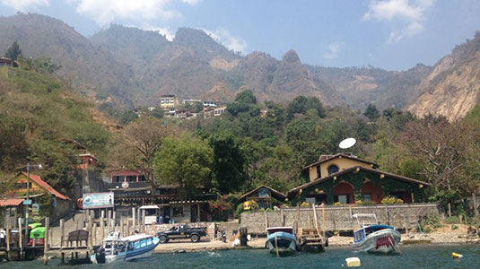

Report from Guatemala

Day 1:
Wednesday 7th March, 10am Arrival at Guatemala City airport, was picked up by Marya Recinos, psychiatrist and Ministry of Health advisor for mental health. She gave an orientation of the Health System in her country including NGO projects she runs in collaboration with Toronto, such as violence against women, addictions and mental health, DRI (disability rights international with Washington). She is also preparing the first draft of mental health law to submit to MoH by the end of this year. The sections so far are conducted via judge, process most of the time is initiated by relatives or legal system-police. To discharge patients from section is a time consuming process as needs authorization by judge, which most of the time results in severe delays in discharging patients from hospital.
The mental health hospital, Federico Mora, is only one for the whole country and has one male ward with 95 beds, psychotic as main diagnosis (dx), one female ward with 35 beds, again psychosis as prominent dx, PICU with 50 beds- admission usually epileptic/LD with aggressive /psychotic behavior, one forensic unit 40-50 beds, staffed by two psychiatrists, one is specialized in forensic, and emergency unit for short admissions, mainly depression with suicidal ideation. There is also an older adult ward, ‘psychogeriatric’ which admits also patients with LD and chronic cases, usually abandoned by family (>60yo).
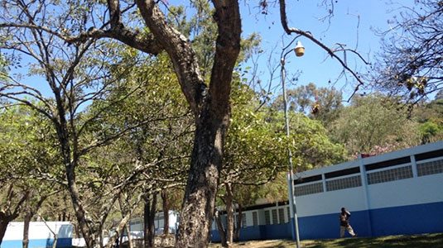
Apart from the crisis unit the rest of the hospital / units, operate as an asylum, with patients staying there for many years. The emergency unit is a new construction and in operation for over a year, initiated by Marya who submitted the proposal to MoH three years ago. It has 10 beds and pts are seen by the on call psychiatrist before admission or discharge.
The psychiatry trainees are called residents and are in various stages of their training, from year one to year 4 which is their last. They do on call from 3pm to 7am and they rotate every 6-7 days. Usually there are 3-4 residents on call and during their normal shift there are 15. They start at 8am. Until 1pm they are in hospital seeing patients and doing ward rounds with the consultants. Then they have ‘classes’ from 2pm to 5pm in the university.
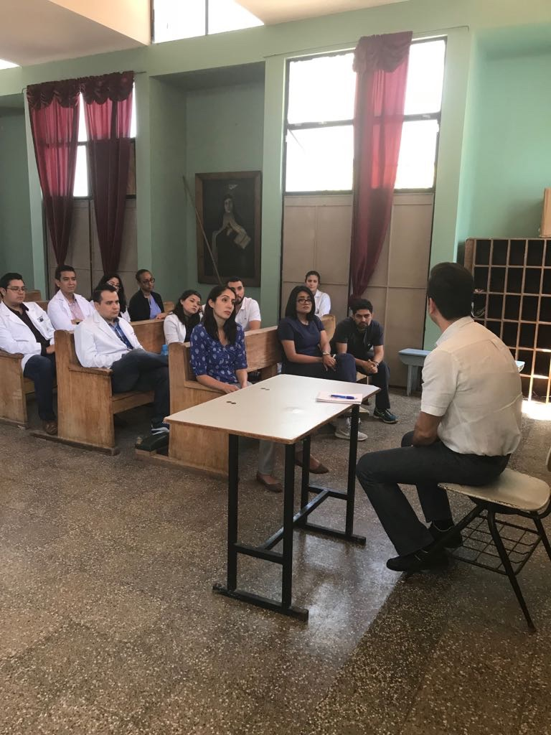
There are six universities with medical schools around the city of Guatemala.
The absconsion rate is high, sometimes patients are brought back by the hospital guards or by police. Other times the family may also bring them back to hospital. Sometimes they never return or heard of them again. There are incidents of suicide in the ward, mostly by hanging. During the on call hours, hospital is understaffed, 1-2 nurses for one ward overnight, whereas 4-5 staff each ward during day time.
There are three meals a day offered to patients. Their inpatient treatment is free of charge, but they need to pay for their medications in the community post discharge.
if a ward exceeds admission capacity which is a common theme, they put mattresses as beds on the floor.
There are six physicians from main hospitals who visit the hospital every day to review pts physical health needs.
Medications:
Mostly oral, because they need to continue in the community with the cheapest form, if they prescribe depot on the ward it is difficult to continue in the community due to cost and need for regular follow up. They avoid prescribing atypical antipsychotic for same reason. Haloperidol, chlorpromazine are the most commonly prescribed. Fluphenazine for depot.
Example:
The cost of haloperidol 28tablets is 125 quetsales, for risperidone is >2000 quetsales Clozapine is a treatment of last resort mainly due to cost, as very expensive.
Regarding anti-depressants; fluoxetine or escitalopram are the most commonly used.
The hospital does not have a psychology department, the volume of patients would not justify it.
Trainees have psychotherapy sessions as part of their training and they run them in the out patient clinic, mainly CBT model.
The short admission emergency ward has an OT dept.
Liaison service runs in the general hospital of Guatemala City which unfortunately we did not have the chance to visit on the day due to running out of time and the resident liaison team had a meeting.
The follow up is very limited, if patients may come from very far away they may never be followed up post discharge as there is no mental health service in rural health centres – apart from Solola where a newly CMHT service has been running over the past 2 years, by Dr Alexandro, Psychiatrist.

Day 2:
Meeting with Dr Lourdes to finalize the teaching program, mhGAP, ToT course:
- 12/3
  - 8-830: registration, coffee, introductions
  - 830-9: situation in Guatemala, (Dr Marya)
  - 9-10:30: introduction to mhGAP, integration model, use of the manual, ( Dr Lou)
  - 10:30-11: Coffee break
  - 11-1300: essential and care practice, ( Dr Pandis)
- 13/3
  - 8-10: Depression , (Dr Pandis)
  - 10-10:30 coffee break
  - 10:30-11:30: depression
  - 11:30-13:00: suicide
- 14/3
  - 8-830: recap (Dr Pandis)
  - 8:30-10:30: psychosis
  - 10:30-11: break
  - 11-13:00: psychosis
- 15/3
  - 8-830: recap (Dr Pandis)
  - 830-10:30: substance misuse
  - 1030-11: break
  - 11-13:00, child and adolescent
  - 13-1330: closure
(Feedback forms provided at the end of each teaching day).

Day 3:
Visit of the Federico Mora hospital with Marya, meeting with the residents and staff including one of the architects, Myriam, who build the new crisis/emergency unit.
After this we were supposed to visit the liaison psychiatry team at the general hospital but ran over time and team had a meeting till end of their shift Day 4: visit of the indigenous populations in Atitlan lake; visit to the health centre at Tzutzuna and Solola hospital. We managed to get in the hospital and visited the in-patient medical, surgical and pediatric ward as well as the general laboratory ward. The psych outpatient clinic was closed as it was Saturday.
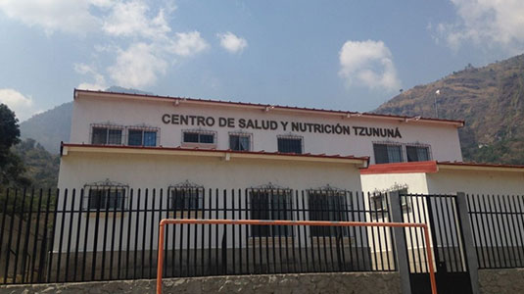

Day 5:
Sunday

Day 6:
Teaching started

Future goal:
To continue training staff in rural health centers who are not specialized in mental health, staff at first level referral centers. Overseas colleagues will organize the venue and come up with suggested dates for next year.

Follow-up and sustainability of the project:
Feedback forms to be sent to delegates in 3 months to measure impact of training in their practice.

