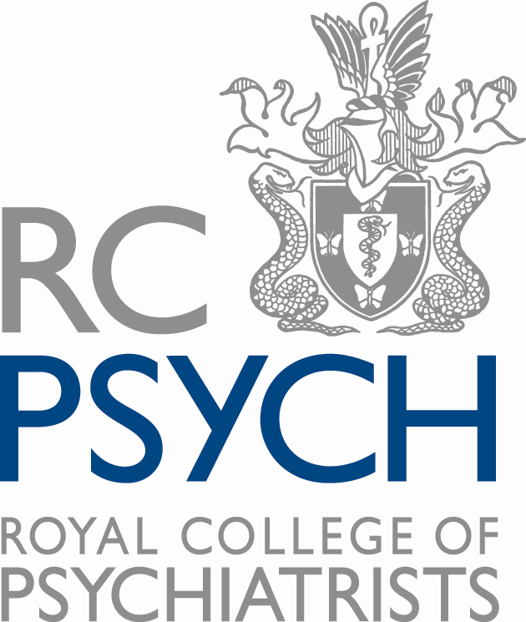

Documentary and film requests

Please complete this form and send to press@rcpsych.ac.uk. We will respond to your request as soon as we can.

Where possible, the Royal College of Psychiatrists will always endeavour to support media work that could benefit the lives of people living with mental illness. However, due to the sheer number of media enquiries we receive, we can only work on projects that have received a definite broadcast commission.

Our decision to support your project is contingent on several factors including the quality and relevance of previous work, whether your work aligns with our values and priorities, and whether we have enough resource to support you.

Name
Phone number
Email address
Address and website of your production company

Which outlet commissioned your proposal? Please attach documentary proof of your commission.

What is the broadcast date if decided?
Please provide details of your previous broadcast work and a link to your video portfolio.
Brief details of your proposal
Brief details of the support you require from RCPsych

