Request for remark of MRCPsych Exams

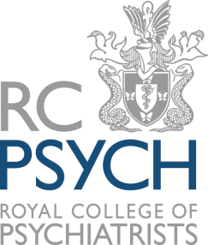

Prior to completing this form, please ensure you have read the
Eligibility Criteria and Regulations for MRCPsych Written Papers and
Clinical Assessment of Skills and Competencies (CASC)

Candidates should complete this form and send with a cheque for £130 made payable to 'The Royal College of Psychiatrists' no later than 14 days after the publication of the results.

Candidate Number
GMC Number (if GMC registered)

Your Details
Surname
Forename
Email Address
Which Written Paper are you requesting to be re-marked?

Paper A (i)
Paper A (ii)
Paper A
Paper B
CASC

Date of the examination

Enclosed:
Cheque for £130 made payable to “The Royal College of Psychiatrists”
Yes
Signature |  | Date
Please print, sign and return by post to:

Head of Examinations Operations
Examinations Unit
Royal College of Psychiatrists
21 Prescot Street
London E1 8BB

