Royal College of Psychiatrists
Pan American
Division Newsletter

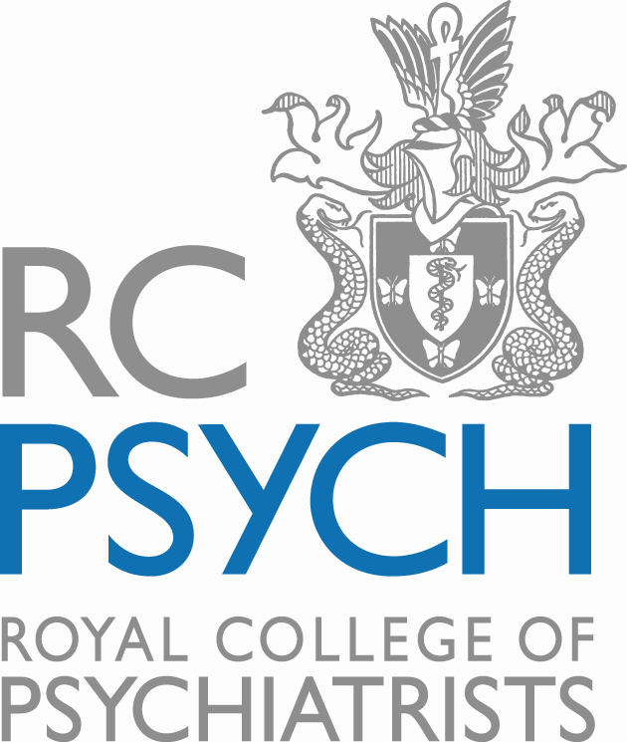

October 2018 (Issue 46)

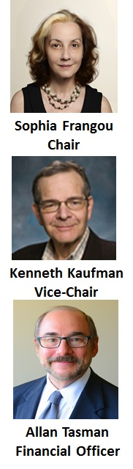
Dear Colleagues
Every once in a while something totally new does come along! In this newsletter we draw attention to three surprising findings recently published in psychiatry and neuroscience.

(a) Opioids and rapid antidepressant response
In an elegant paper in the American Journal of Psychiatry colleagues from Stanford University showed that opioid receptor antagonism by naltrexone prior to the administration of intravenous ketamine attenuated its acute antidepressant effects. The effect was so substantial that the investigators terminated the trial early. The article is accompanied by a thought provoking editorial from Dr. Mark George from the Department of Psychiatry and Behavioral Sciences and the Institute of Psychiatry, Medical University of South Carolina.

(b) New uniquely human brain cells?
Scientists working to inventory human brain cells using microscopy and genetic analysis identified a new GABAergic neuron that appears to have no counterpart in mice. As reported in Nature Neuroscience they named the new cells rosehip neurons because of their unusually large and bulbous axonal boutons. Rosehip neurons comprise 10% to 15% of the neurons in the first layer of cortex and appear positioned to exert significant inhibitory influences; however, their precise role in the complex circuitry of the brain remains to be determined.

(c) Is air pollution lowering cognitive abilities?
In a paper published in PNAS researchers from China and the US examined the language and arithmetic abilities of 20,000 Chinese citizens performance on language and arithmetic tests and related them to levels of local nitrogen dioxide and sulfur dioxide pollution. High pollution levels were associated with lower scores in these test scores, equivalent on average to having lost a year worth of education. The effect was more pronounced in men, less educated individual and in individuals older than 64 years.

We hope you find these studies interesting and informative.

As always we want to hear from you! Email us at panamericandivision@rcpsych.ac.uk
Sophia Frangou Kenneth Kaufman Allan Tasman
This and That
Job Board
The Job Board can be accessed at http://jobs.rcpsych.ac.uk/home/index.cfm?site_id=16082 The site accepts job postings from employers and allows job seekers to search for jobs and create personalized alerts based on their interests. Please note that the postings are international (not just UK) and include clinical and academic posts at all levels of seniority.

Medical Training Initiative
The Medical Training Initiative (MTI) is designed to enable a small number of International Medical and Dental Graduates to enter the UK to experience training in the NHS for up to two years before returning to their home country. For more details including how to apply please visit the College’s website at https://www.rcpsych.ac.uk/workinpsychiatry/internationalaffairsunit/medicaltraininginitiative.aspx

RCPsych PanAm Book club
The book club features books (recommended by our members). The topic has to be relevant to psychiatry and neuroscience from either a scientific, literary or societal perspective. Self-nominations by authors who are college members are welcome. Please provide a brief comment for each recommendation but this is optional. Any ideas? Please send them in at panamericandivision@rcpsych.ac.uk! NB: Inclusion of a book in the PanAm Book Club does not imply endorsement or promotion by the RCPsych.

Book of the Month
Computational Psychiatry: New Perspectives on Mental Illness
By A. David Redish and Joshua A. Gordon (Editors) (Strüngmann Forum Report, The MIT Press; 1st edition 2016)

Previously featured
What is Real?
By Adam Becker (Basic Books 2018)

Advice for a Young Investigator
By Santiago Ramón y Cajal (translated by Neely and Larry W. Swanson) (A Bradford Book; 1st edition 2004)

The Knife Went In: A Prison-Doctor on Britain's Dark Side
By Theodore Dalrymple (Gibson Square Books Ltd, Revised edition 2018)

Maps of Meaning: The Architecture of Belief
By Jordan Peterson (Routledge; 1st edition March 1999)

The Maudsley Prescribing Guidelines in Psychiatry, 13th Edition
By David M. Taylor, Thomas R. E. Barnes and Allan H. Young (Wiley Blackwell, 2018)
This is the updated edition of the word-leading and essential reference book for the prescribing of drugs for patients with mental health disorders.

Neuroexistentialism
By Gregg Caruso and Owen Flanagan (Oxford University Press, 2018)

Soul Made Flesh: The Discovery of the Brain--and How it Changed the World
By Carl Zimmer (Atria Books; Reprint edition, 2005)

Dreamland: The True Tale of America's Opiate Epidemic
By Sam Quinones (Bloomsbury Press; Reprint edition 2016)

Behave: The Biology of Humans at Our Best and Worst
By Robert M. Sapolsky (Penguin Press, 2017)

Against empathy: A case for rational compassion
By Paul Bloom (HarperCollins, 2016)

The Unity-Based Family: An Empirical Study of Healthy Marriage, Family, and Parenting
By HB Danesh and Azin Nasseri (Cambridge Scholars Publishing, 2017)

Brain Apps: Hacking Neuroscience To Get There
RG Best and JM Best (Booklocker.com, 2017)

The Grey Zone: A Neuroscientist Explores Border Between Life And Death
By Adrian Owen (Scribner, 2017)

When Breath Becomes Air
By Paul Kalanithi (Random House, 2016)

Brainwashed: The Seductive Appeal of Mindless Neuroscience
By Sally Satel, Scott O. Lilienfeld (Basic Books, 2015)

The Ministry of Utmost Happiness
By Arundhati Roy (Knopf, 2017
For all of you who love India and “The God of Small Things”

The Mask of Sanity
By Jacob Appel (Permanent Press, 2017)

Introduction to Syndemics: A Critical Systems Approach to Public and Community Health
By Merrill Singer (Jossey-Bass, 2009)

Head in the Cloud: Why Knowing Things Still Matters When Facts Are So Easy to Look Up
By William Poundstone (Little, Brown and Company, 2016)
Walking the Medicine Wheel: Healing Trauma & PTSD
By David Kopacz and Joseph Rael (Beautiful Painted Arrow)
Millichap Books/Pointer Oak, 2016

Re-humanizing Medicine: A Holistic Framework for Transforming Your Self, Your Practice, and the Culture of Medicine
By David Kopacz (Ayni Press, a division of John Hunt Publishing, 2014)

The Emotional Life of Your Brain
By Richard J. Davidson, Sharon Begley
Avery; Reprint edition (December 24, 2012)

Journeys into the Bright World
by Marcia Moore and Howard Alltounian (Para Research, 1978)
Freely accessible at http://pdf.textfiles.com/books/journeysbrightworld.pdf

The Doors of Perception
By Aldous Huxley (Harper Perennial Modern Classics 2009)

The Age of Wonder: The Romantic Generation and the Discovery of the Beauty and Terror of Science
by Richard Holmes (HarperCollins, 2008)

Marijuana: The Unbiased Truth about the World’s Most Popular Weed
By Kevin Phill (Hazelden 2015)

Algorithms to Live By: The Computer Science of Human Decisions
By Brian Christian and Tom Griffiths (Henry Holt and Co 2016)

Why You Love Music: From Mozart to Metallica--The Emotional Power of Beautiful Sounds
By John Powell (Little, Brown and Company 2016)

Introductory Textbook of Psychiatry, Sixth Edition
By Donald W. Black and Nancy C. Andreasen (APA 2014)
(Comment by Sophia Frangou: A good textbook for residents and students updated to reflect changes in the DSM5)

Sacred Pathways: The Brain's role in Religious and Mystic Experiences
By Todd Murphy; Foreword by His Holiness The Dalai Lama and A. Persinger; 2015

NeuroTribes: The Legacy of Autism and the Future of Neurodiversity
By Steve Silberman (Penguin 2015); Winner of the 2015 Samuel Johnson Prize for non-fiction

The Digital Doctor: Hope, Hype, and Harm at the Dawn of Medicine's Computer Age
By Robert Wachter (McGraw-Hill Professional 2015)

The Well-Tuned Brain: Neuroscience and the Life Well Lived
By Peter Whybrow (WW Norton & Company 2015)

The Heart and the Bottle
By Oliver Jeffers (HarperCollins Publishers 2015)
(Comment by Sophia Frangou: An unbelievably tender book that helps children understand death and loss; it is also available as an animated film read by Helena Bonham-Carter: https://itunes.apple.com/gb/app/heart-bottle-for-ipad/id407795360?mt=8)

Gratitude
By Oliver Sachs (Knopf 2015)

A Passion for Science: Stories of Discovery and Invention
By Suw Charman-Anderson (Editor) (Kindle ebook 2015)

Furiously Happy: A Funny Book About Horrible Things
By Jenny Lawson (Flatiron Books 2015)

Brain Renaissance: From Vesalius to Modern Neuroscience
By Marco Catani and Stefano Sandrone (Oxford University Press, 2015)

Shrinks: The Untold Story of Psychiatry
By Jeffrey A. Lieberman and Ogi Ogas (Little, Brown and Company, 2015)

The Future of the Brain: Essays by the World's Leading Neuroscientists
By Gary Marcus and Jeremy Freeman (Princeton University Press, 2014)

Drugs, Without the Hot Air
By David Nutt (UIT Cambridge, 2012)

