HOGARTH REVISITED
Clementine Maddock

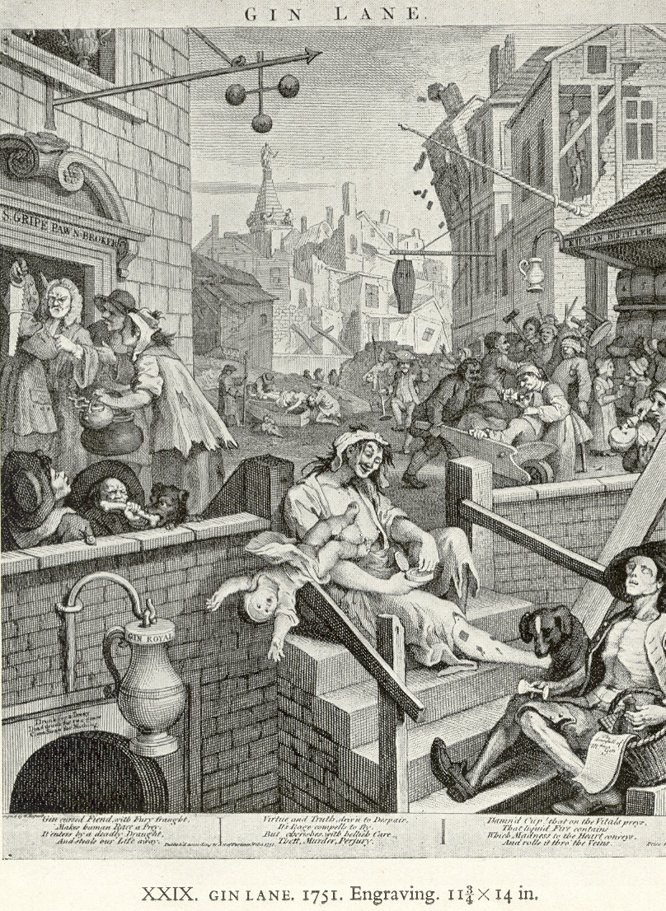

Gin Lane appears to be a long way from present day society- a syphilitic prostitute letting her baby fall to it’s probable death, the carpenter pawning his saw, the skeletal ex-soldier who has sold all his clothes to pay for gin, the black dog symbolising despair and depression, fighting in the street, and two young girls, wards of the Parish of St Giles, already succumbing to the habit. The only people succeeding are the undertakers and the pawnbrokers. Sadly, these scenes are all conjured up in my day to day encounters with patients at the drug and alcohol team in which I work, in a once thriving industrial town.
Having spent nearly twenty years working in deprived areas of inner city London, I was surely hardened to poverty and need? However, I wasn’t prepared for the stories that I would start to hear; five-year-olds fed on ‘bong’ pipes by their drug addicted mothers, childhood sexual abuse and physical abuse, and at best, benign neglect. I am unused to patients who started injecting heroin at the age of eleven. While I haven’t seen a case of syphilis, sex working is not uncommon to pay for drugs. Hepatitis C virus is all too common as a result of injecting heroin, amphetamines or more recently “meow”. While many of our patients experienced neglect and cruelty from their own parents, the cycle is perpetuated; one mother attended with her child in one hand, starving and only dressed in his pyjamas, and bottle of brandy in the other, saying she couldn’t cope. Another mother sold her children’s birthday presents for £30 for a few bags of heroin. Taken together with the high rates of mental illness, history of imprisonment, and neglect of all other activities to sustain the substance dependence, and Hogarth doesn’t seem such a distant world away.
The flip side of the coin is that treatment can work. What does treatment mean? Heroin addiction can be managed by offering substitute medication, such as methadone or buprenorphine, in combination with psychological and social support. While critics may argue that detoxification from illicit drugs is the only way forward and doctors should not be perpetuating addiction by keeping patients dependent on a medication such as methadone or buprenorphine, the evidence tells us that substitute treatment works. When a patient can stop selling themselves or their children’s toys to feed their habit, other important changes can start to take place. Patients talk about feeling ‘normal’ again- going for a walk in the park, starting to rebuild relationships, getting back into work. The risk of infections, heart problems, and blood borne viruses such as hepatitis B, hepatitis C and HIV is reduced when injecting has been replaced by methadone or buprenorphine. This is not to say that the substitute treatments are life-long; patients are given opportunities and support to detox at a rate that they can tolerate.
Substitute opiate treatment is not a panacea; these medications are themselves toxic in overdose, particularly if taken with alcohol and benzodiazepines such as diazepam. To ensure safety at the beginning of treatment patients are asked to attend daily at their pharmacy for supervised consumption. There is always a risk, despite these safeguards, that medication is diverted onto the streets thus perpetuating community drug problems. Supervised consumption of medication can feel stigmatising and cause problems with people who have jobs to hold down. Nevertheless, the evidence demonstrates that patients who stay in treatment are at reduced risk of death by overdose, have reduced criminal convictions, and can start to rebuild their lives.
As I was writing this, I went into one of the team offices and asked for some success stories to illustrate the point. K, a key worker, was recently contacted by the local diabetic nurse. “What have you done with P?” she asked, “he’s like a changed man. He looks well and he’s really managing his diabetes properly”. P had come into our service as an injecting drug user with poor diabetic control and multiple suicide attempts. He spent his day seeking and using drugs. He was treated with methadone for two years and during this time started to rebuild his relationship with his family, took control of his diabetes, and both his physical and mental health improved. He now enjoys walking and fishing. He slowly reduced his methadone dose and has now been drug free for the past two years.
We do not know what happened to the characters in Hogarth’s Gin Lane. Partly due to the outcry caused by this print the Gin Act was passed which saw a reduction in the levels of gin production; perhaps replaced by beer, the saviour drink according to Hogarth’s partner print in this series, Beer Street. For the modern day characters from Hogarth, there is some hope; treatment can work and Gin Lane is not the road of no return.

