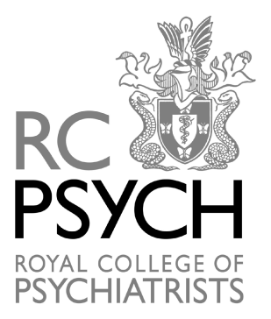

OBITUARIES

COUNCIL MEETING – 7 July 2023

(Since the Council meeting on the 21 April 2023)

Campbell, Clara
Member ~ Over 40 Years member

Campbell, Patrick Brendan
Member ~ Over 40 Years member

Corbett, John Anthony
Fellow ~ Over 40 Years member

Eastwood, Jenny
Fellow ~ Over 40 Years member

Kennedy, Robert Ian
Fellow ~ Over 40 Years member

Lintner, Brenda
Fellow

Perez Gil, Antonio Juan Jose
Member ~ Over 40 Years member

Samuel, Michel Sadek
Fellow ~ Over 40 Years member

Shafiq, Muhammad Mudassar
PMPT

Stephens, Douglas Alan
Fellow ~ Over 40 Years member

Tompkins, Errol Bernard
Member

